Snapshots:

1. Create a new Xcode project named “CCTB_Snapshot” using the view-based template in a NEW folder named “CCTBSnapshots”
2. Add a Workspace to be associated with the newly created project.
   1. File-> Save As Workspace : snapshotWorkspace in the same folder that the project was created in.
   2. Xcode should have added the file “**snapshotWorkspace.xcworkspace**” to the folder you created in step 1.

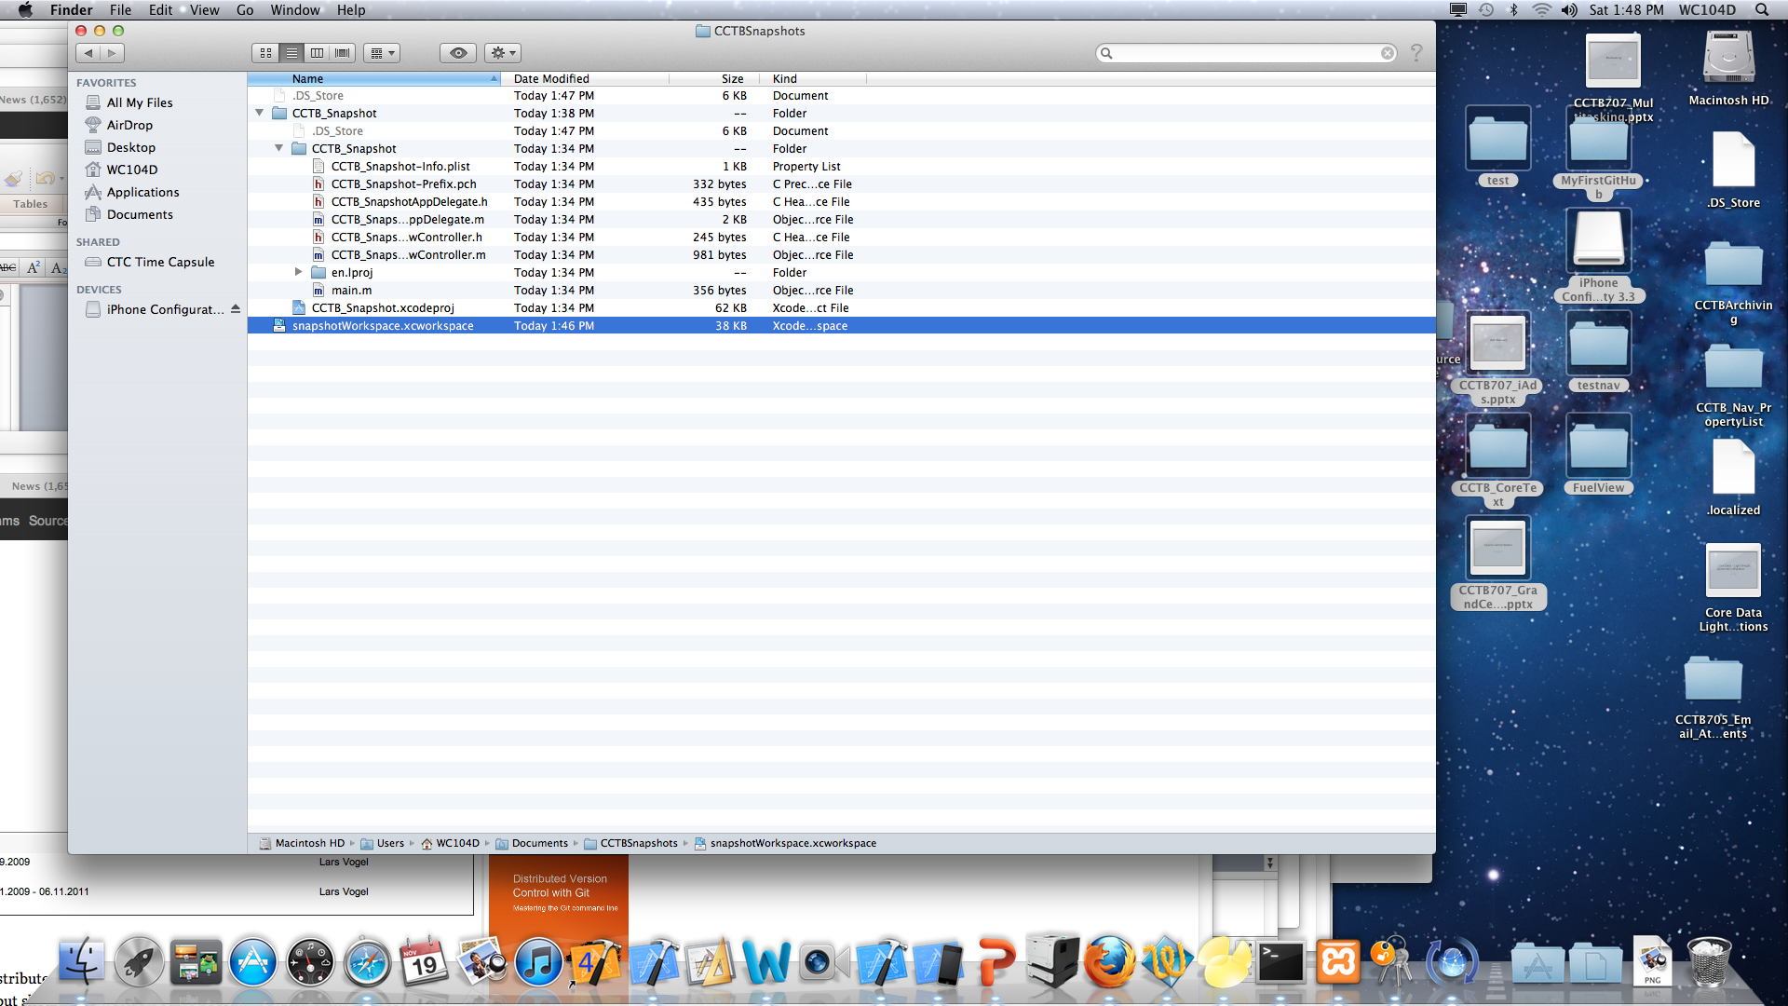

1. To create a snapshot File-> Create Snapshot->Name: snapshot1 Description: This is the first snapshot prior to changes in Interface Builder. -> Create Snapshot  
   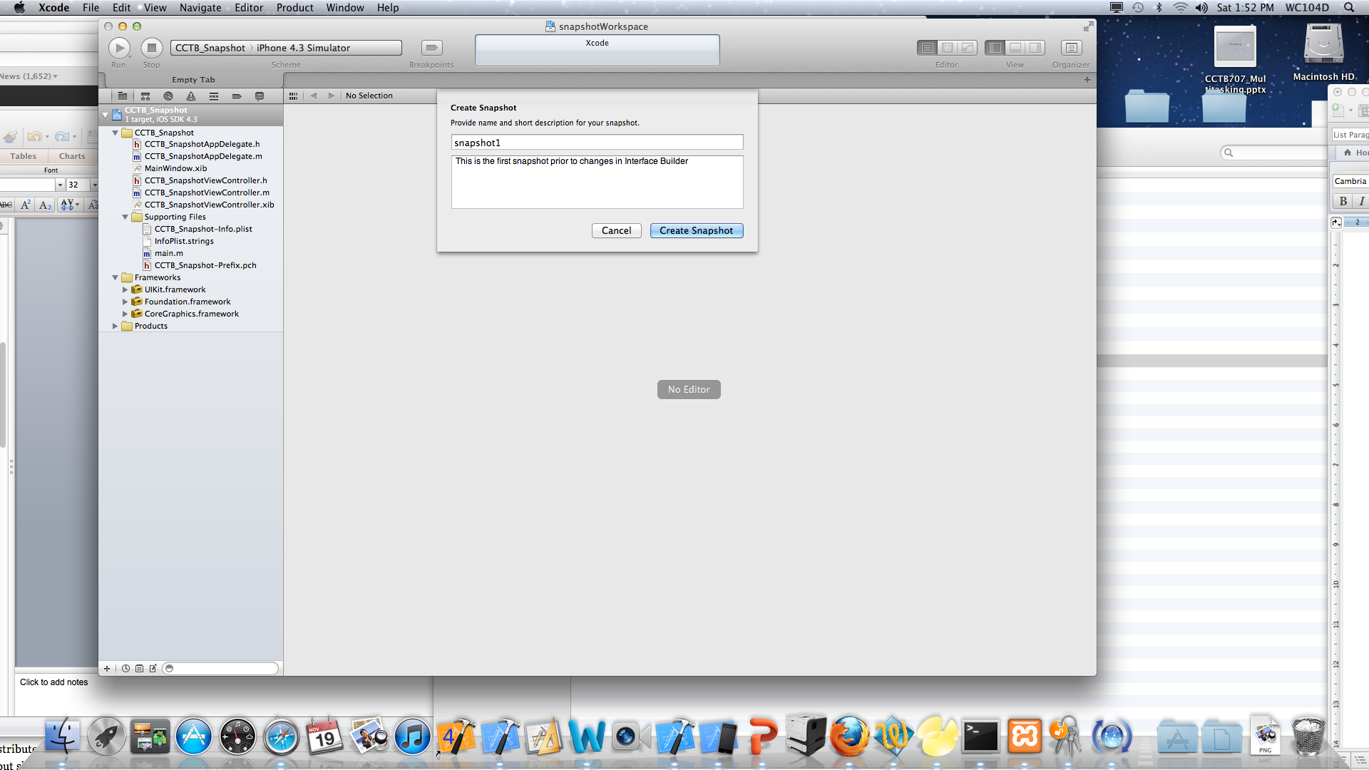
2. Note that the only visual indicator of the workspace is the label change in the top-middle section of Xcode:

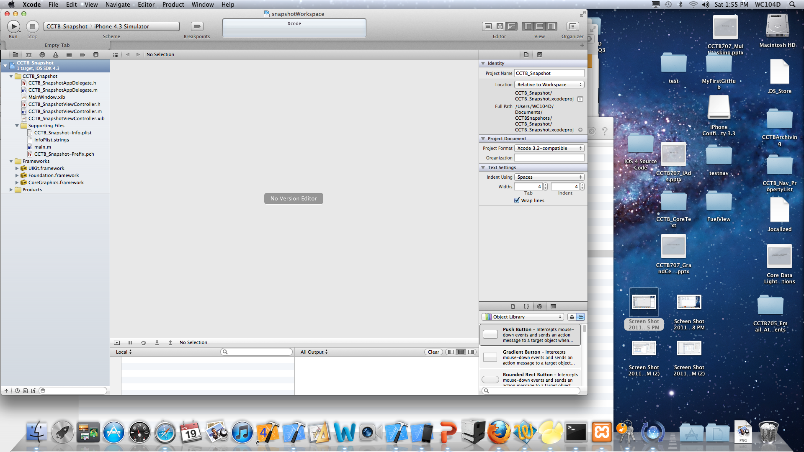

1. Open the “**CCTB_SnapshotViewController.xib**” and change the background color of the view.
2. Run the application with the new background color of the view. Note: Sometimes the project may crash so you may need to Stop and re-Run the application.
3. Make another snapshot: File-> Create Snapshot (See figure below):

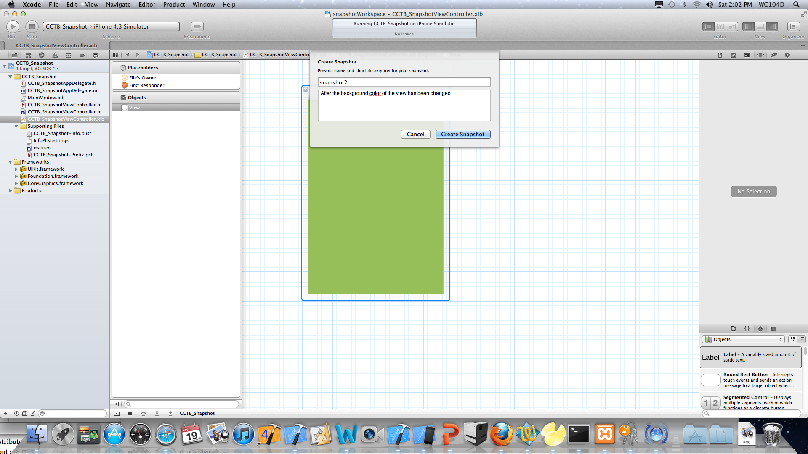

1. To view the snapshots contained within the workspace: Window->Organizer->Select the Projects Icon

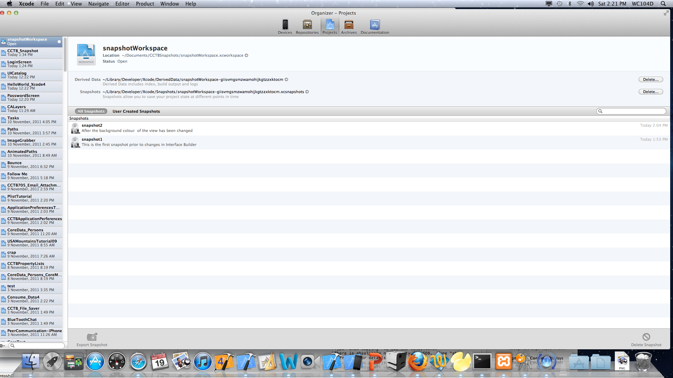

1. Note that Organizer has your two snapshots.
2. To restore a project to its previous settings File-> Restore Snapshot->select snapshot1->Restore

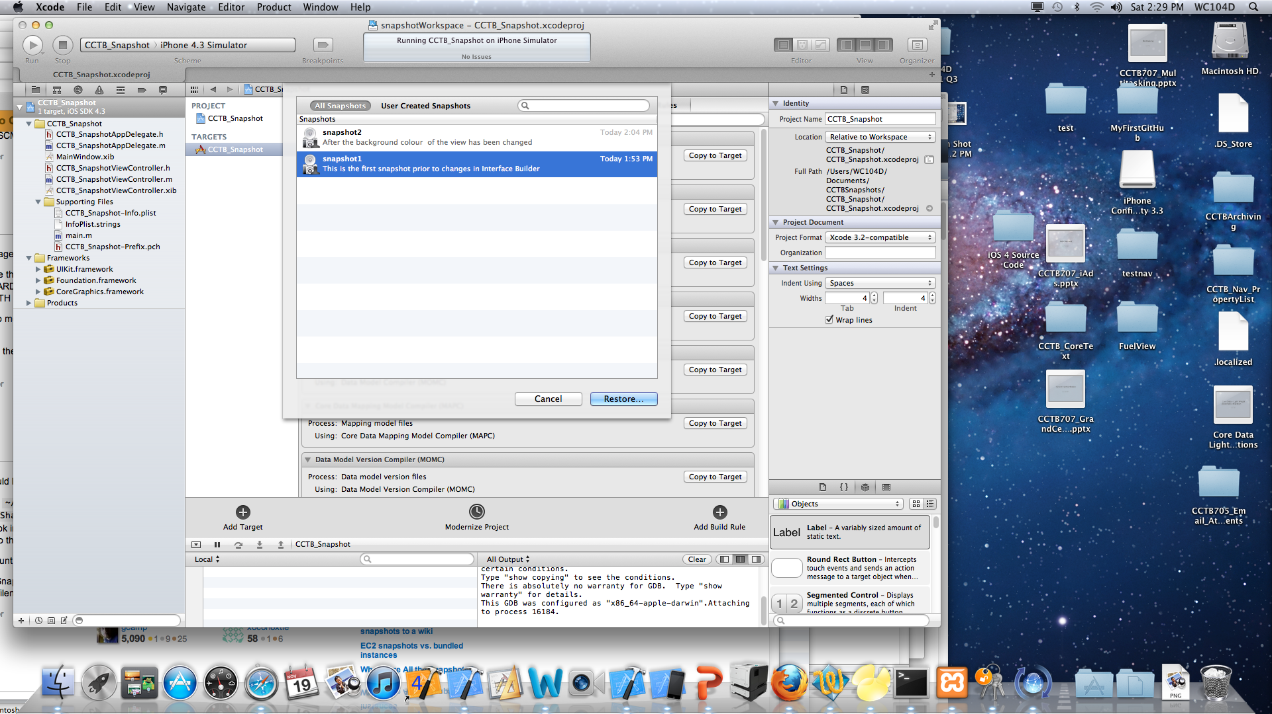

1. Xcode will open the snapshot and current version side by side so that the developer can compare the files (In our case we made changes to the .xib).
2. Select the Restore button and Xcode will ask is you would like Xcode to create an automatic snapshot-> Select Enable
3. Open Organizer and note that a NEW snapshot has been created. The NEW snapshot is the same as snapshot2, but has been created by Xcode. You should be able to toggle between all snapshots and the one(s) that you created.

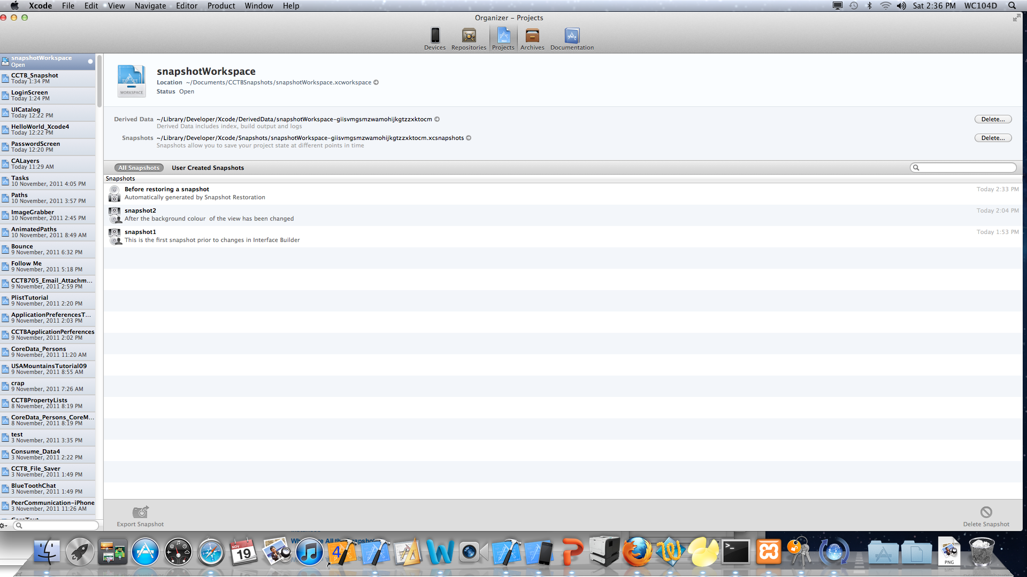

14.0Run the application and note the color of the view.

15.0 Restore the application to the snapshot2 snapshot and Run the application.